ASSIGNMENT : 3

1.
Enable Multi-Factor Authentication (MFA) on your personal AWS or Azure cloud account using the built-in authenticator app option, and take a screenshot of the MFA setup confirmation page.
ANS :
Steps :
- Logged in to the AWS Management Console.
- Opened Security Credentials from the AWS account menu.
- Under Multi-Factor Authentication (MFA), clicked Assign MFA device.
- Selected Authenticator app as the MFA device.
- Scanned the QR code using Google Authenticator.
- Entered two consecutive 6-digit MFA codes generated by Google Authenticator.
- Clicked Add MFA.
- The Security Credentials page showed the MFA device as Virtual, confirming that MFA was successfully enabled.
Screenshot : AWS Security Credentials page showing successful MFA configuration using a virtual authenticator app.
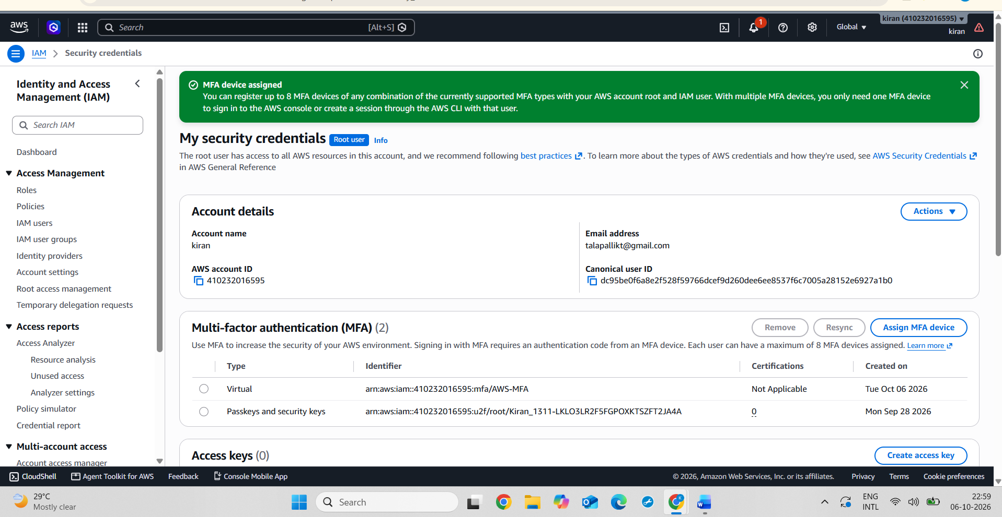
2.
Simulate a login to your cloud account from a new browser or incognito mode and document the steps and prompts you receive with MFA enabled.
ANS :
Steps :
- Opened a new Incognito browser window.
- Opened the AWS login page.
- Entered my AWS login credentials.
- Selected Authenticator app for MFA verification.
- Opened Google Authenticator and entered the 6-digit MFA code.
- Successfully logged in to the AWS Management Console.
Screenshot : AWS Management Console successfully opened after MFA verification using the authenticator app.
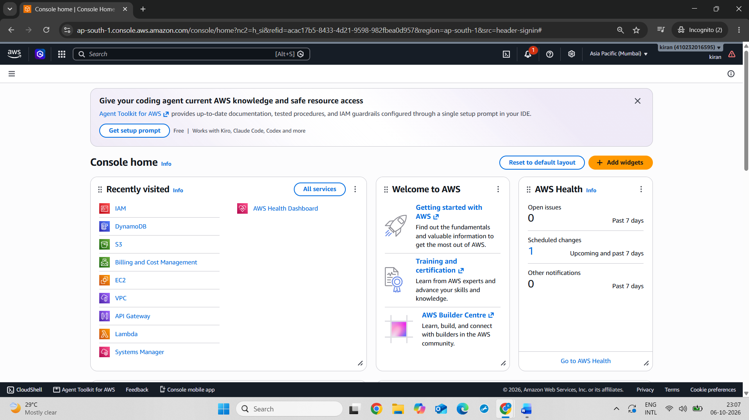
3.
Disable MFA temporarily on your cloud account, attempt to log in again, and note the difference in the login experience and security prompts.<br><br><em><strong>Hint:</strong> Compare the number of steps and any warnings shown with and without MFA.</em>
ANS :
Steps :
- Opened the AWS Management Console.
- Opened Security Credentials from the AWS account menu.
- Under Multi-Factor Authentication, selected the configured authentication method.
- Disabled/deleted the passkey used for additional authentication.
- Signed out of the AWS Management Console.
- Opened a new Incognito browser window.
- Entered the AWS account login credentials.
- Signed in without the passkey verification.
- AWS opened the Management Console directly without the additional security prompt.
- Compared the login experience with MFA/passkey enabled and disabled.
- Enabled MFA again after completing the test to keep the AWS account secure.
Screenshot : AWS login page showing the Passkey/Security Key authentication option configured for secure account access.
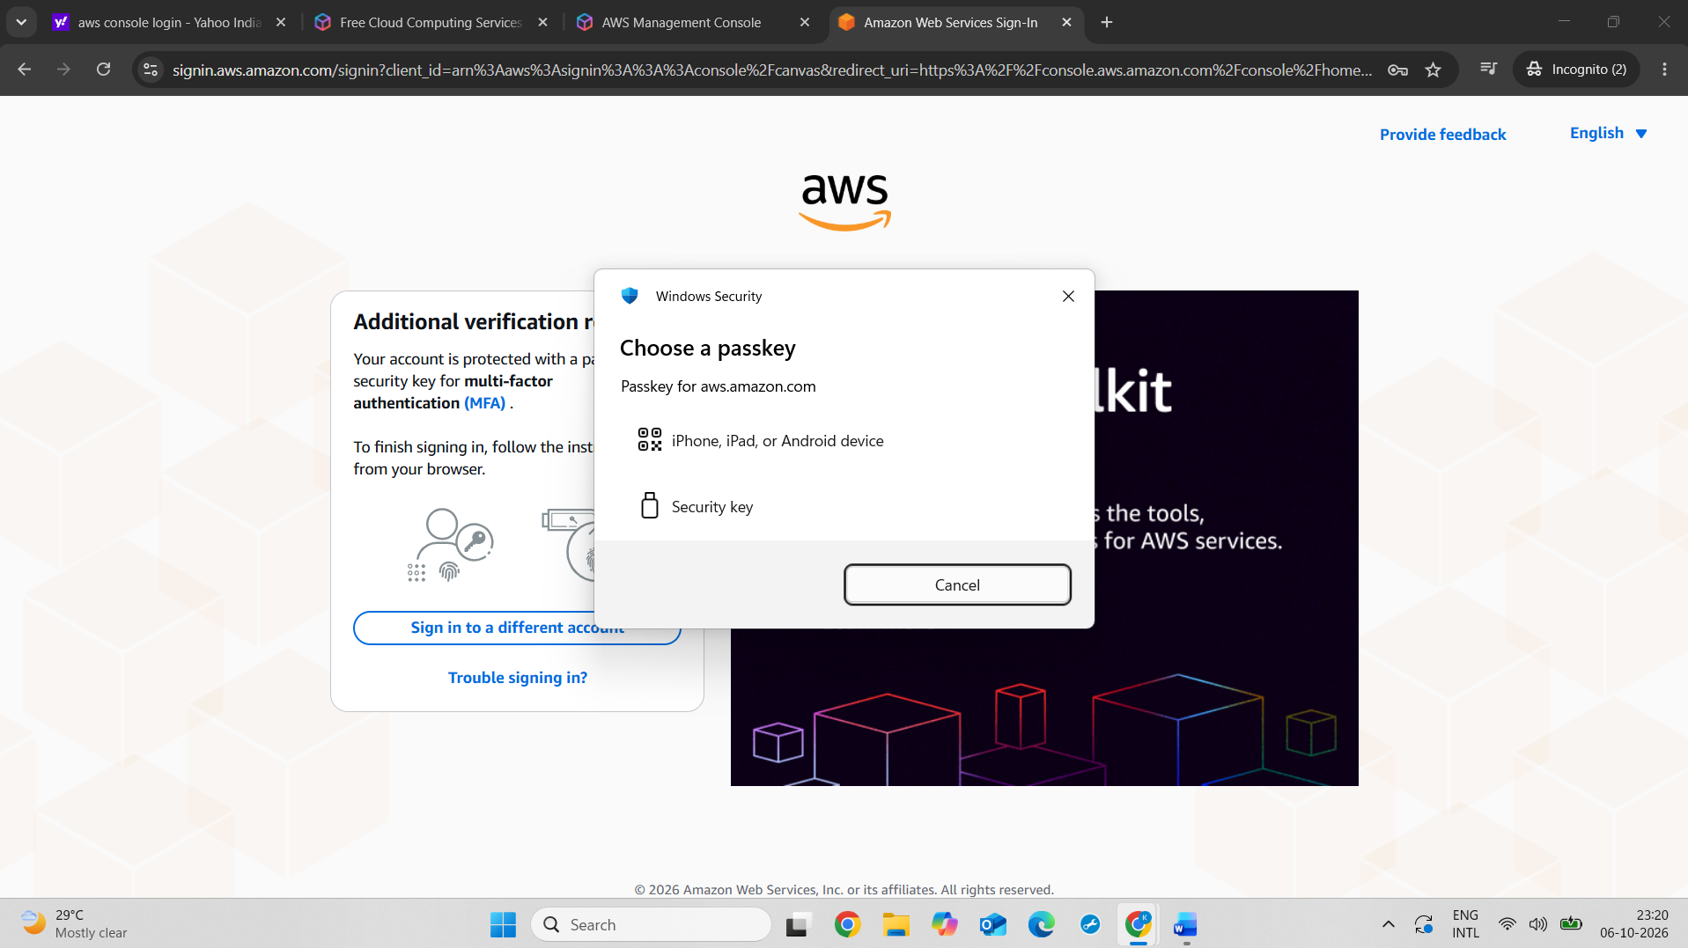
Screenshot : AWS login after disabling the passkey, showing direct access to the AWS Management Console without passkey verification.
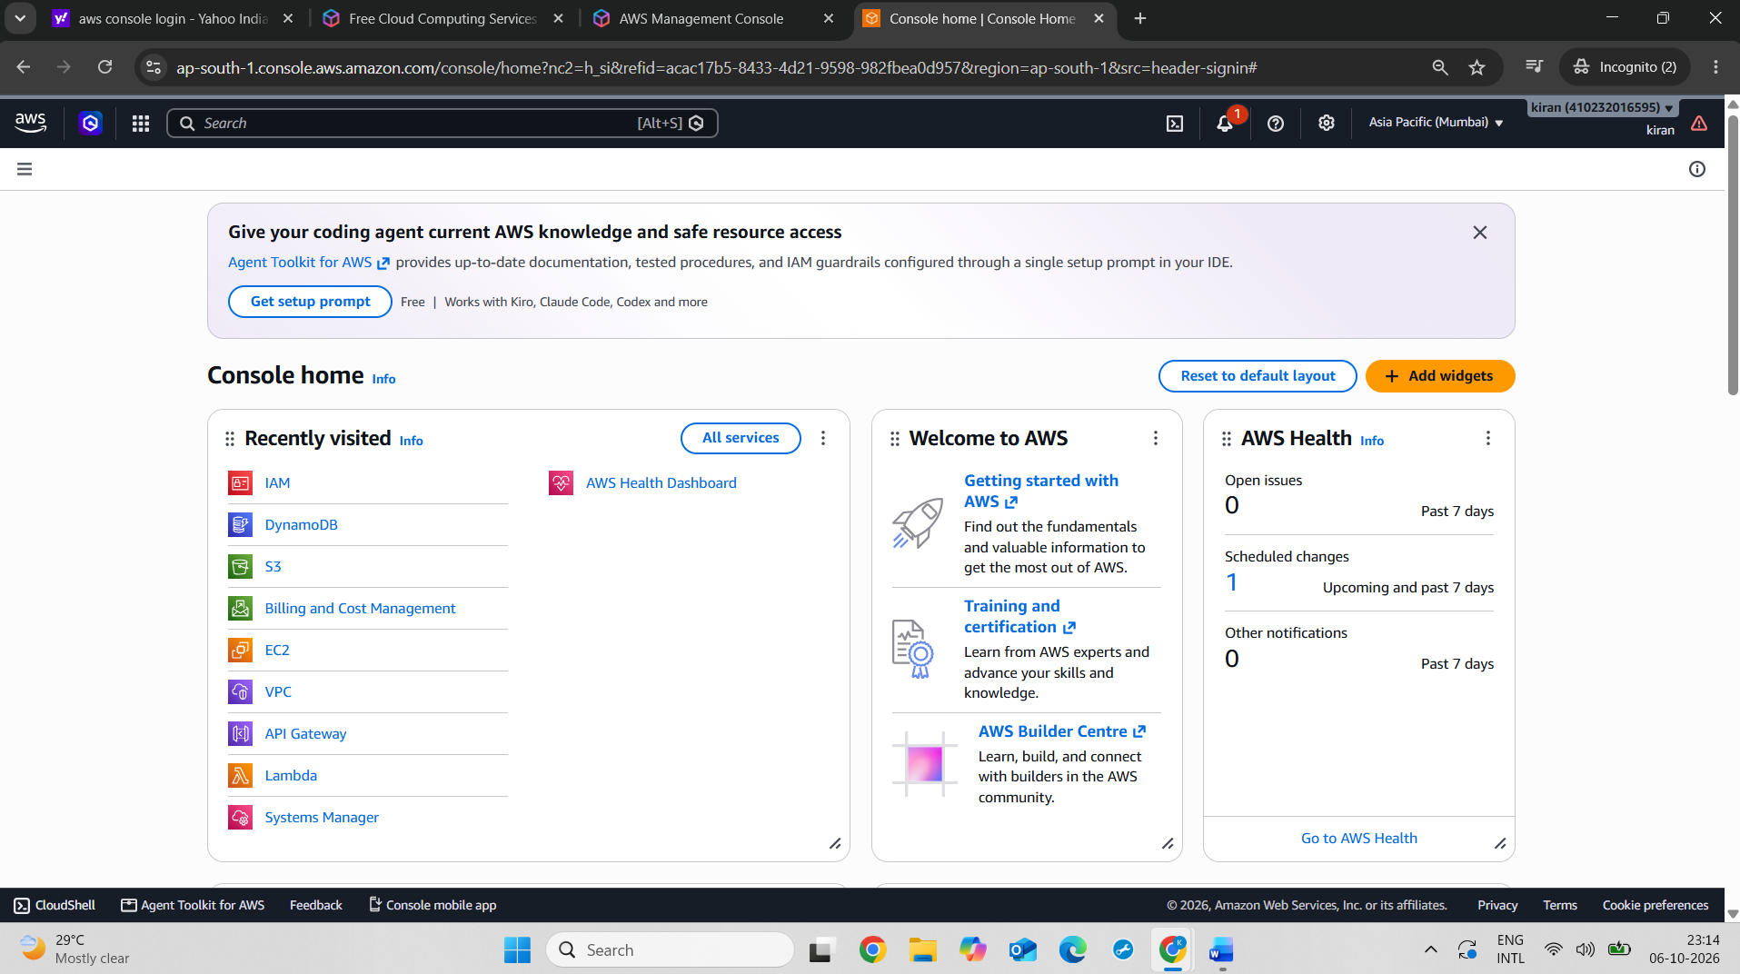
4.
Write a short scenario (3-5 lines) describing how an attacker might try to access a cloud account without MFA, and explain how enabling MFA would block or alert you to this attempt.
ANS :
Scenario:

An attacker may obtain a user's AWS username and password through phishing or a stolen password. Without MFA, the attacker could use these credentials to log in to the cloud account. When MFA is enabled, AWS also requires a valid verification code from the user's authenticator app. The attacker cannot complete the login without this second factor, so MFA helps block unauthorized access.

